“Bharathium Isaiyum (Bharathi and Music)”
2+ HOURS OF TAMIL DRAMA, DANCE, MUSIC & POETRY

This not-to-be-missed unique dance-music-drama is a thematic presentation of Bharathi’s compositions, put together by CMANA and curated & led by Isaikkavi Ramanan from Chennai; our immense thanks to musician Rajkumar Bharathi, great grandson of Bharathi, for providing originals & setting some songs to tunes.

Who is Bharathi & Who is Isaikkavi Ramanan ?

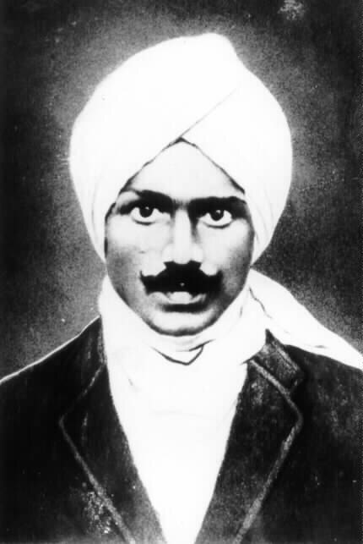
Chinnaswami Subramaniyan (1882- 1921), popularly known as Subramania Bharathi or Mahakavi Bharathi (or simply as Bharathi), was an Indian poet, composer, writer, translator, journalist, teacher, Indian independence activist, social reformer and polyglot. Bharathi was well-versed in several languages and had a passion for Tamil, his mother tongue. He was bestowed the title Bharathi for his poetry when he was hardly ten years old; and was a pioneer of modern Tamil poetry and prose. His works covered political, social and spiritual themes. His impactful works included patriotic songs composed during the early stages of the Indian Independence movement. He fought for the emancipation of women, was against child marriage, supported widow re-marriage, opposed the caste system, and advocated reforms of the society and religion. A true ‘national’ poet extraordinaire and a world citizen, he epitomized the dictum ‘The Pen is Mightier than the Sword’.
On the music side, Bharathi was self-taught on Carnatic Music and almost always included a ragam and a taalam/mettu for his songs.

.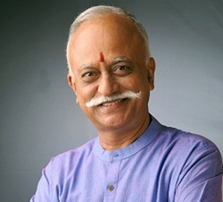
Ramanan who hails from Chennai, has enriched the world of performing arts with his talents as a thinker, writer, poet, actor, speaker, singer, photographer and performer. As a public speaker Ramanan provokes, stimulates and entertains – no matter whether the topic is literature, music, cinema, theatre, spirituality or culture. Ramanan is also a prolific writer. He has published 40 books in Tamil, five in English; and translated three books from English to Tamil and one from Tamil to English. Ramanan has received numerous awards and recognitions including the prestigious Kalaimamani Award from Tamil Nadu , but says the title “Isaikkavi” is the one he cherishes the most.
On stage, Ramanan looks, walks, and talks like Bharathi. In real life, he also thinks and writes like Bharathi. As a blog says, Ramanan ‘breathes’ Bharathi!
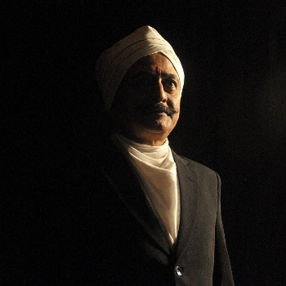

This program is a homage to this great patriot and poet, celebrating his contributions via powerful dialogs by Isaikkavi Ramanan, our own Stage Friends Ramani and xx; and via innovating dancing & soulful signing by artistes, teachers, and students from the NJ/PA/NY region. It is notable that the selected songs and dances cover varied themes around patriotism, spiritual devotion, women power, social reforms, love, and nature. Many songs are recognizable as they have been popularized by leading musicians.

Kudos to these artistes for bring Bharathi’s songs to life on stage today!!

